**CI-CD PIPELINE IN JENKINS**

1. Dockerhub token created

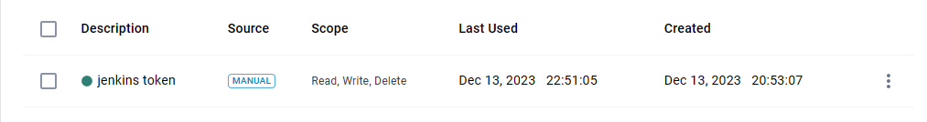

1. Configured Dockerhub credential in Jenkins

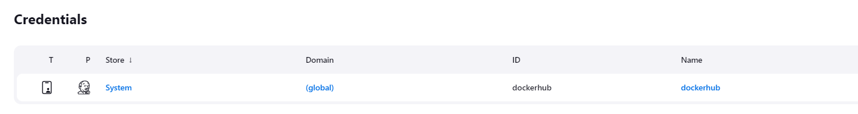

1. Configured webhook in Git

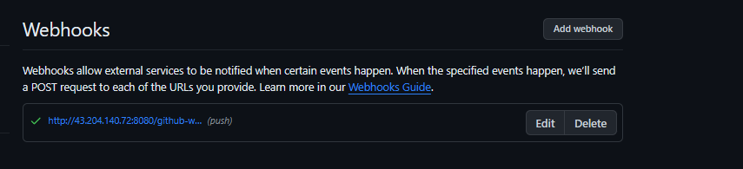

1. Creating environment variables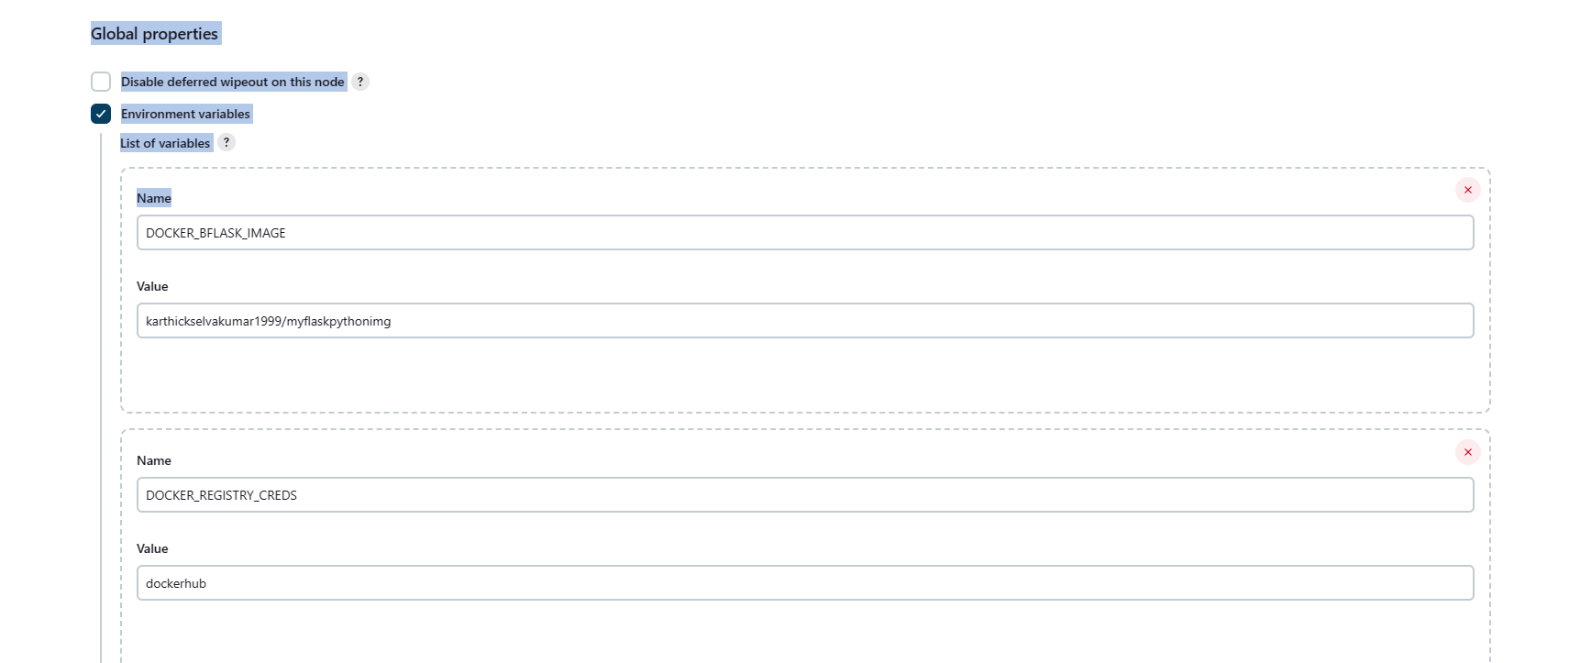
2. Added E-mail notification

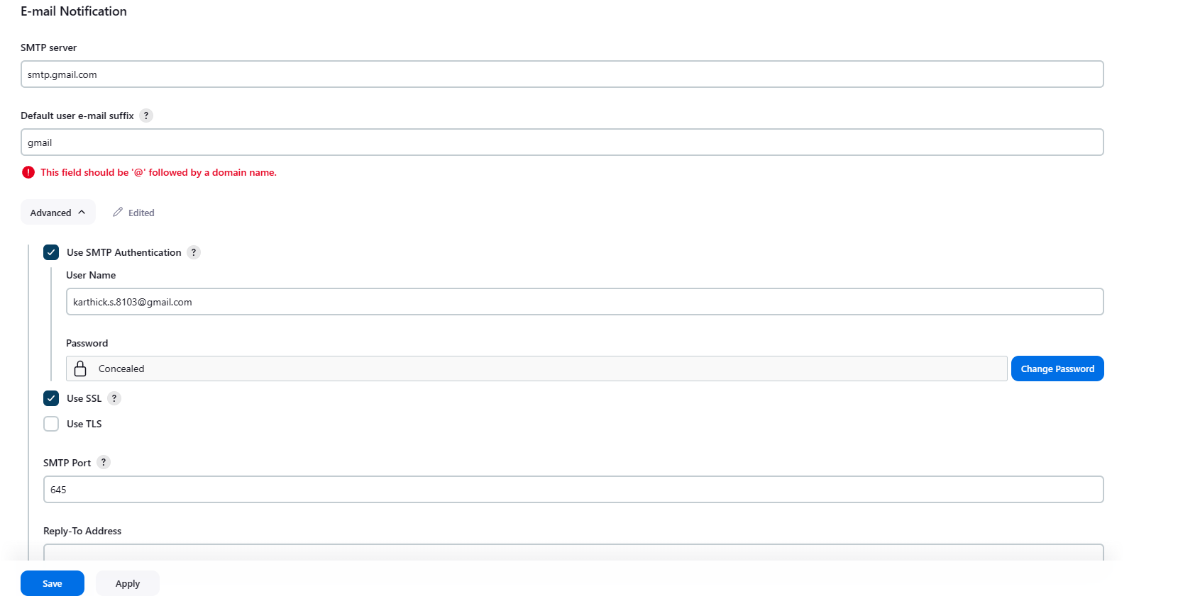

1. Pushed to Dockerhub repository

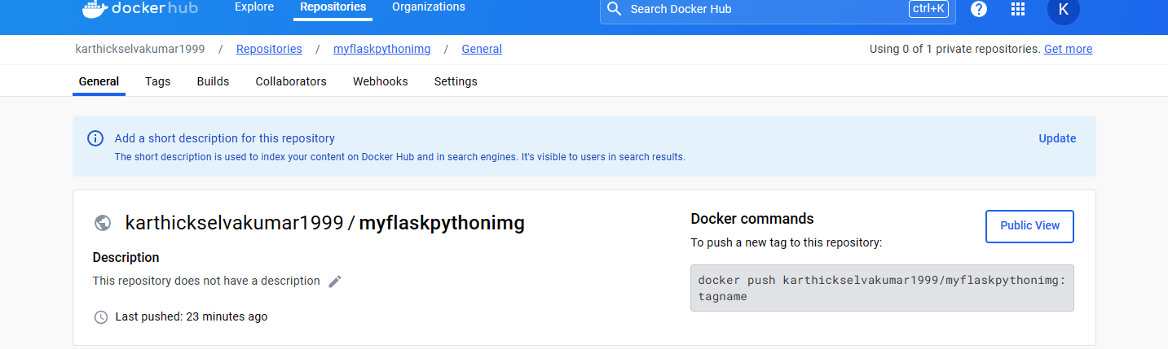

1. Output in browser

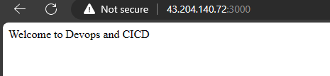

1. Output via mail

